

Tribhuvan University
Institute of Science and Technology

A Final Year Project Report
On
College Management System with Grade Prediction

Submitted To
Department of Information Technology
Kathford International College of Engineering and Management

In partial fulfillment of the requirement for the Bachelor Degree in Computer Science and Information Technology

Submitted By
Abhinav Singh Thapa (79010398)
Babita Subedi (79010404)
Khusi Dahal (79010410)

Under the Supervision of
Suwas Karki

March 2026

ACKNOWLEDGEMENT
We would like to express our sincere appreciation to Kathford College of IT, Balkumari, Lalitpur, for providing the essential resources, facilities, and continuous support throughout the duration of our project. The college’s strong dedication to academic excellence and practical learning has greatly contributed to enhancing our knowledge and skills, making this experience both valuable and memorable.
We are deeply grateful to our supervisor, Mr. Suwas Karki, for his valuable guidance, continuous encouragement, and unwavering support, all of which played a significant role in the successful completion of this project. We also extend our thanks to the faculty and staff of Kathford College of IT for their cooperation and assistance in creating a positive and supportive learning environment.
Finally, we would like to acknowledge the hard work and collaboration of our team members, whose commitment and teamwork were essential in achieving our project goals. We are equally thankful to our classmates and peers for their encouragement and constructive discussions, which continuously inspired us to put forth our best efforts.

ABSTRACT
College Management System with Grade Prediction is a web based application designed to manage academic activities and predict student performance using machine learning. The system collects student data such as attendance, internal marks, assignment scores, and other academic records. Unlike traditional systems that only store data, this system analyzes the data using algorithms like Random Forest, Decision Tree, and Support Vector Machine (SVM) to predict the final grades of students.
The system provides role-based access for admin, teachers, and students. Admin manages the system, teachers update and monitor student data, and students can view their performance and predicted grades. This approach helps identify weak students at an early stage so that teachers can take necessary actions. Overall, the system improves academic management, reduces manual work, and supports better decision-making through data analysis.
Keywords: Grade Prediction, Machine Learning, Student Performance, Random Forest, Decision Tree, Support Vector Machine, Data Analysis, Web Application, Academic Management

TABLE OF CONTENTS
ACKNOWLEDGEMENT 2
ABSTRACT 3
1.1 Introduction 5
1.2 Problem Statement 6
1.3 Objectives 8
1.4 SCOPE AND LIMITATION 9
1.5 DEVELOPMENT METHODOLOGY 10
2.1 Background Study: 12
2.2 . Literature Review 13
2.2.1 Study of Existing System/Literature Review 13
1.1.1 Non-Functional Requirements 15
3.1.2 Feasibility Analysis 16
ii.Operational feasibility 17
3.1.3 PROCESS MODELING USING DATA FLOW DIAGRAM 19
LEVEL 0: DATA FLOW DIAGRAM 19
4.1.2 LEVEL 1: DATA FLOW DIAGRAM OF EMPLOYEE 20
4.2 ALGORITHM DETAILS 23
4.2.1 Random Forest 23
4.2.2 Linear Regression 23
5 IMPLEMENTATION DETAIL 24
REFERENCES 25
APPENDICES 27
SCREENSHOTS 27

1.1 Introduction
The rapid growth of technology has changed how educational institutions manage their academic activities. Colleges today handle a large amount of student data such as attendance, assignments, and examination results. Managing this data manually is time-consuming, error-prone, and inefficient. Therefore, there is a need for a smart and digital system that can handle academic data in an organized and reliable way.
Traditional college management methods mainly focus on storing data but lack advanced features like analysis and prediction. These systems do not provide insights into student performance, making it difficult for teachers to identify weak students early. As a result, institutions often depend on multiple tools or manual processes, which leads to data duplication, inconsistencies, and inefficient management.
In such situations, teachers and administrators use different systems for attendance, results, and student records. This creates confusion and makes it difficult to manage all information in one place. The lack of a centralized system also affects decision-making, especially when trying to improve student performance based on data.
To solve these problems, this project proposes a College Management System with Grade Prediction, a web-based application that combines academic management and intelligent prediction in a single platform. The system includes features such as student record management, attendance tracking, result management, and grade prediction using machine learning algorithms like Random Forest, Decision Tree, and Support Vector Machine.
From an operational point of view, the system reduces manual work, improves data accuracy, and saves time for both teachers and administrators. Academically, it helps in identifying students who need extra support by predicting their performance in advance. Technically, the project demonstrates the use of modern web technologies such as HTML, CSS, JavaScript, React, and backend tools like Noorde.js or Python with databases like Postgresql.
Overall, this project provides a smart and efficient solution for managing college activities. It improves productivity, supports better decision-making, and enhances student performance through data-driven insights.

Problem Statement
Educational institutions often rely on manual or partially digital systems to manage student records such as attendance, assignments, quiz results, and academic performance. These traditional methods are time-consuming, difficult to manage, and may lead to errors or data inconsistency. Although some systems are digitized, they mainly focus on storing data rather than analyzing it for meaningful insights.
Therefore, there is a need for a smart and efficient system that not only manages student data but also uses machine learning to predict academic performance. Such a system should help teachers identify at-risk students early and take necessary actions to improve their outcomes.
The increasing use of digital systems in education has also revealed several limitations in existing college management approaches. Many institutions use separate systems for attendance, result management, and student records, which creates inefficiencies in handling academic data and decision-making.
Three key challenges emerge from this situation:
- Data Fragmentation and Inconsistency:
Student information is often stored in different systems such as attendance records, exam databases, and assignment files. This leads to data duplication, inconsistency, and difficulty in getting a complete view of student performance.
- Inefficient Administrative Processes:
Teachers and administrators need to switch between multiple systems to manage attendance, marks, and reports. This process is time-consuming and increases the chances of human errors.
- Lack of Performance Analysis and Prediction:
Traditional systems do not provide tools for analyzing student data or predicting future performance. Without prediction, it becomes difficult to identify weak students early and take preventive measures.
Addressing these challenges requires an integrated system that combines data management with machine learning techniques. Such a system can centralize all academic information, reduce errors, improve efficiency, and support better decision-making to enhance student performance.

Objectives
- To providing a web-based system to store student records and perform complex CURD for school functionality.
- To enable accurate final grade prediction (G3) using machine learning models for every student.
- To deliver targeted insights by identifying the most influential performance factors (e.g., attendance, assignments) and recommending actionable steps to improve outcomes for every student.

SCOPE AND LIMITATION
    - Scope:
The project focuses on the development and implementation of a College Management System with Grade Prediction to efficiently manage student data and analyze academic performance. The key areas covered in this project include:
Student Data Management:
Storing and maintaining student records such as attendance, internal marks, quiz scores, and other academic details.
Grade Prediction:
Using machine learning models like Random Forest, Decision Tree, and Support Vector Machine to predict student grades based on historical data.
Role-Based Access:
Providing different access levels for admin, teachers, and students. Admin manages the system, teachers update and monitor data, and students can view their performance.
Performance Monitoring:
Analyzing student performance and identifying weak students based on predicted results for early improvement.
Visualization:
Displaying student performance data in a simple and understandable format using basic charts or reports.

    - Limitations:
- Limited dataset may reduce prediction accuracy and miss some student behaviors
- Only basic machine learning models are used, limiting detection of complex patterns
- Weak security and limited scalability may cause unauthorized access and performance issues

DEVELOPMENT METHODOLOGY
This project requires an agile development approach, as the application must respond to changes and uncertainties by being flexible, adaptable, and refined based on feedback.
Agile methodology is a structured approach that segments projects into manageable phases, focusing on continuous improvement. The model breaks down large projects into smaller, more manageable chunks, which can result in a software product that is the culmination of multiple smaller iteration.
Agile is particularly well-suited for large and complex projects that can be easily divided into smaller parts. In this project, a structured approach was followed, where the work was broken down into smaller sections that were delivered and tested frequently. Each iteration lasted one to three weeks, and the application was refined based on the feedback received.
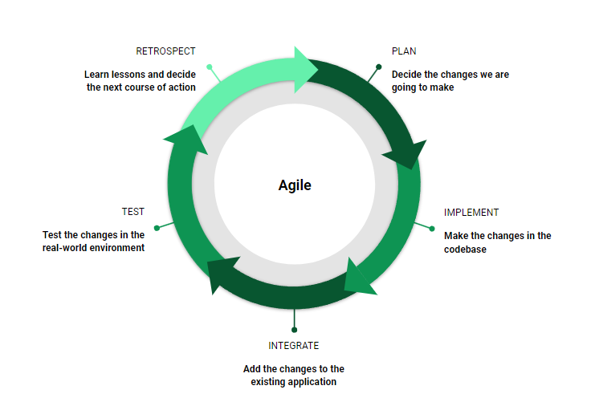
Fig 1.1 Agile Development Methodology
CHAPTER 2: BACKGROUND STUDY AND LITERATURE REVIEW

Background Study:
Traditionally, colleges managed their academic activities using manual or separate digital systems. Student records such as attendance, assignments, and exam results were handled through registers, spreadsheets, or basic software. While these methods worked individually, they created many problems when managing large amounts of student data, leading to errors, duplication, and inefficiency.
Integrated Academic Management System
A modern college management system combines different academic activities into a single platform. It allows administrators, teachers, and students to access and manage information easily. The system handles various tasks such as attendance tracking, assignment management, and result processing in an organized way. However, traditional systems mainly focus on data storage and lack advanced features like performance analysis and prediction.
Centralized College Management System
A centralized College Management System aims to manage all academic data in one place. It reduces the need for multiple systems and improves efficiency. The system provides features such as:
Attendance Management – Teachers can record attendance, and students can view their attendance records.
Assignment & Result Management – Teachers can upload assignments and results, and students can access them easily.
Grade Prediction (ML-Based) – Machine learning algorithms analyze past data to predict student performance and identify weak students.
Reports & Analytics – The system generates reports on student performance, attendance, and academic progress.
Role-Based Access
Different users in the system have different roles such as admin, teacher, and student. Role-based access control ensures that each user can only access the features related to their role. For example, teachers can manage marks and attendance, while students can only view their data. This improves security and proper system usage.

. Literature Review

Study of Existing System/Literature Review
The integration of Machine Learning (ML) into educational systems has significantly enhanced the capability to predict student academic performance and identify at-risk learners at early stages.
Ensemble learning techniques, particularly Random Forest (RF), have demonstrated superior performance in academic prediction tasks. Agyemang et al. [1] reported that RF achieved higher predictive accuracy compared to alternative machine learning approaches due to its ability to capture nonlinear relationships and reduce overfitting through bootstrap aggregation. Similarly, Xu and Yang [4] concluded that RF outperforms Multiple Linear Regression (MLR) when interdependencies exist among factors.
Despite RF’s strong predictive power, Linear Regression (LR) remains widely used because of its simplicity and clear description. Kayes et al. [5] emphasized that LR provides clear explanations, allowing educators to understand how factors such as attendance and prior grades influence final academic outcomes in simple way.
Research in IEEE Transactions on Learning Technologies [3] highlights the use of predictive analytics to identify students at risk of dropout through early academic signals. Moreover, AI-driven student success predictors discussed in Computers in Human Behavior [2] demonstrate high forecasting accuracy when sufficient and well-structured data is available, making the systems accurate and results easy to determine.
Existing Nepali platforms such as Paathshala [6] provide essential College Management System (CMS) functionalities including student profile management, attendance tracking but they do not integrate machine learning-based grade prediction or early warning analytics for identifying academically at-risk students. In many Nepali colleges digital systems mainly store records but do not analyze them. This creates a gap between data collection and meaningful academic insight.
-prone and time-consuming. Existing digital tools may manage records but lack predictive analytics to identify at-risk students early. Literature shows that Random Forest and Linear Regression models improve grade prediction accuracy.

3.1.1 Requirement Analysis
I. Functional Requirements:
User Registration & Authentication
- Secure account creation and login for teachers and administrators.
ii. Teacher Data Entry
- Input student attendance, G1/G2 marks, and assignment submissions.
iii. Admin Student Management
- Register new students and manage student profiles.
- Manage teacher accounts and student records
iv. Grade Prediction (G3)
- Predict final grades using Random Forest or Linear Regression model
v. Performance Factor Analysis
- Random Forest model feature function identifies the most influential factor for each student
- Insights is given to help student by working on the factors which causes grade depletion

Non-Functional Requirements
Reliable data storage: Safe database that stores data in a reliable way and doesn’t loses entries.
Fast Prediction System: Grade predictions show in under 30 seconds, pages load quickly
Authentication: Safe login for teachers/admins.
Uptime: System available 99% of time.
Performance: Works smoothly for 5 teachers using it at once, handles 50 students and the model data should be accurate enough to be trusted it in the future

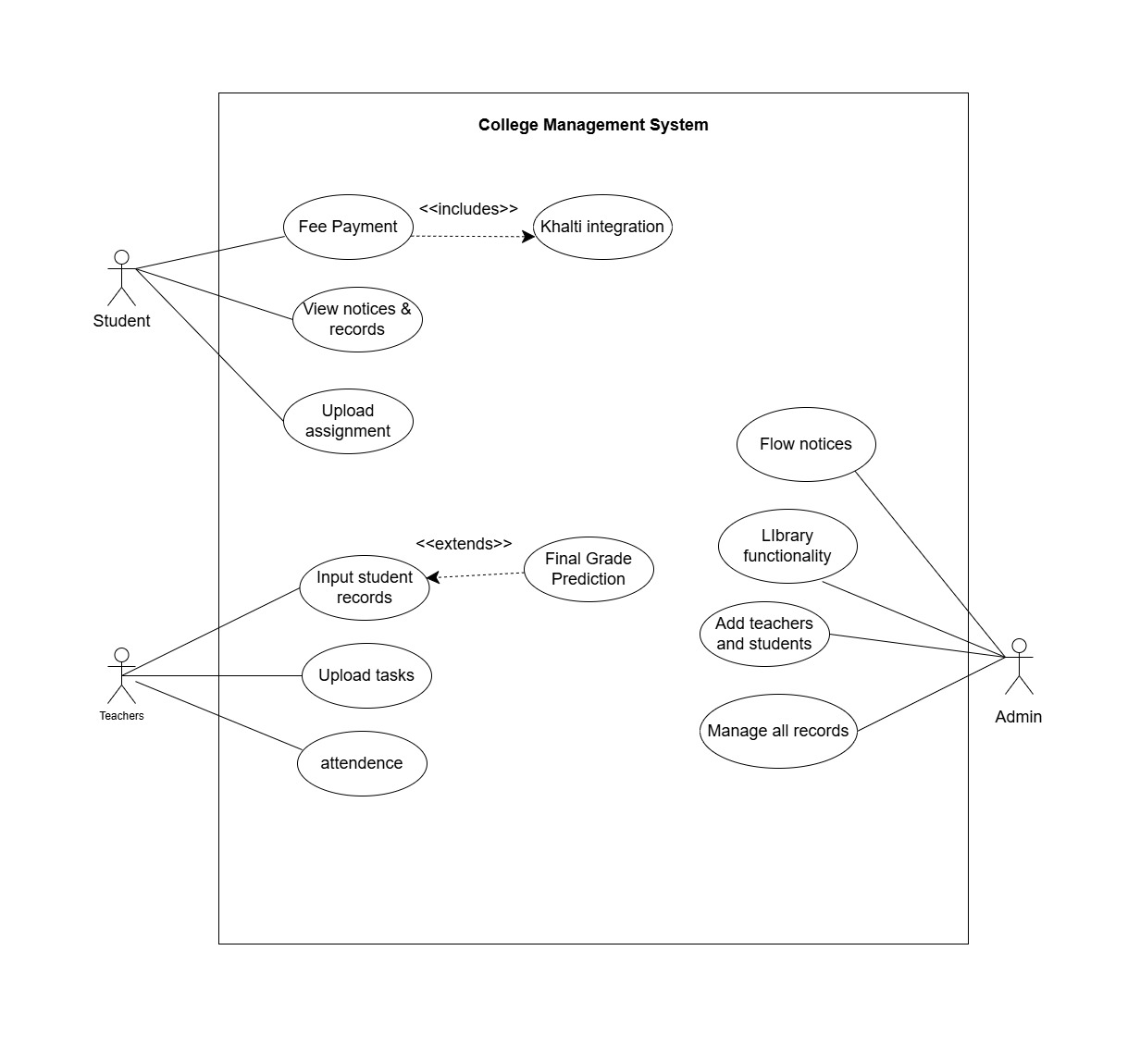
fig: use case diagram

Feasibility Analysis
The feasibility study for the system, aims to assess whether the project is achievable in terms of technical, operational ,economic, schedule feasibility.
i.Technical Feasibility
The project uses open-source, free, well-established technologies with ample resources over the internet. React.js handles the responsive web frontend, Node.js with Express manages backend logic and APIs, while SQLite/PostgreSQL ensures reliable data storage for student records. Scikit-learn implements the Linear Regression and Random Forest ML models. These technologies are technically feasible for college project.

ii.Operational feasibility

The web-based system is simple to use and doesn't require technical expertise Teachers input student records easily, administrators handle registrations, this is all done in a user-friendly web-based forms. This can be adopted easily in campus environment.
iii.Economic feasibility
There is no requirement of external hardware apart from student devices. Also, all the technologies being used (React, Nodejs) and hosting services will be free to use. Datasets to train the model will also be extracted from open source. Hence it is economically feasible.

iv. Schedule feasibility
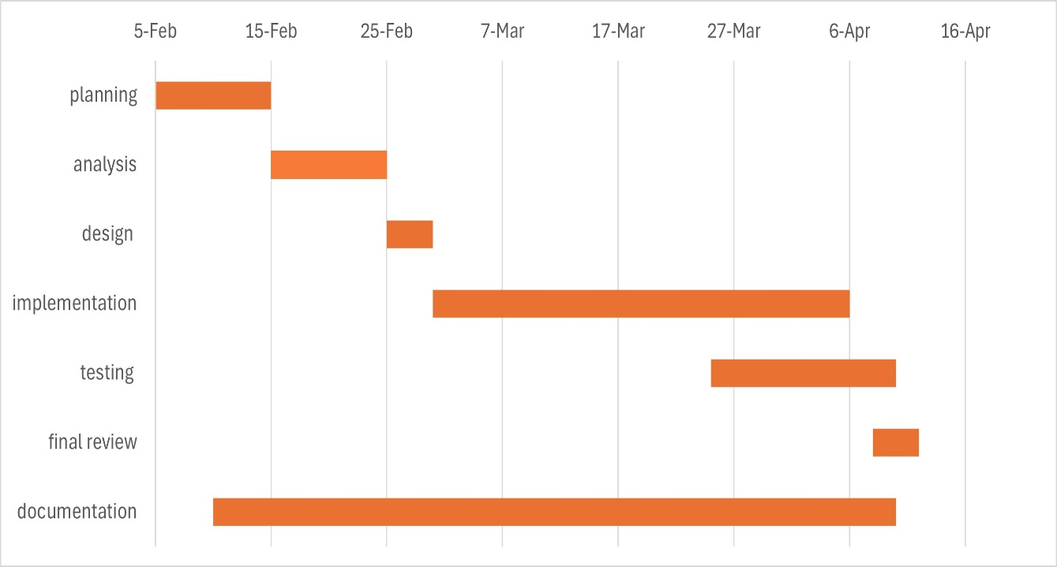
Figure 3: Gantt Chart Breaking Down Project Life Cycle

PROCESS MODELING USING DATA FLOW DIAGRAM

LEVEL 0: DATA FLOW DIAGRAM
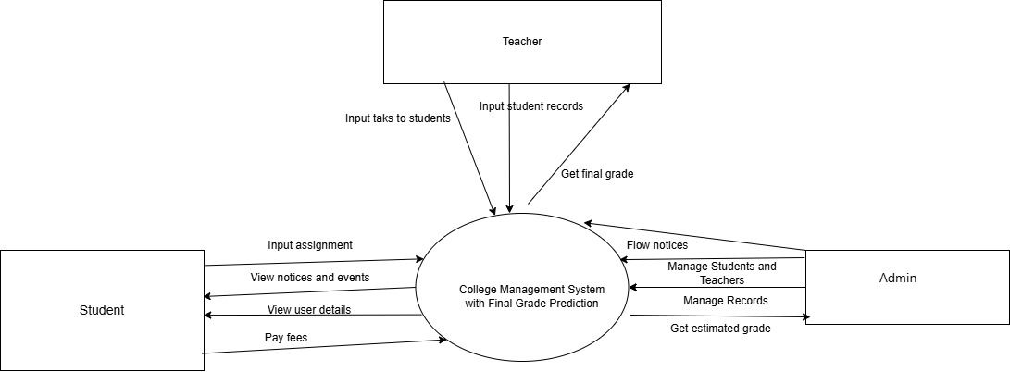
- Figure 6 Level 1: Data Flow Diagram of employee

LEVEL 1: DATA FLOW DIAGRAM OF EMPLOYEE

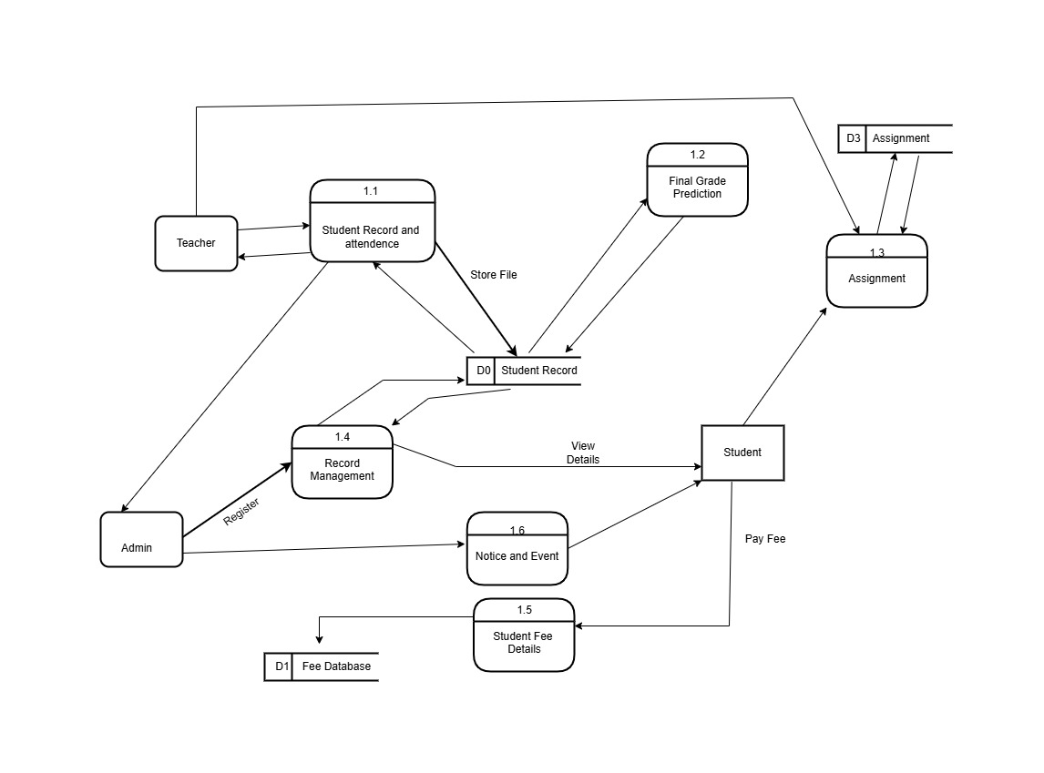

Figure 6 Level 1: Data Flow Diagram

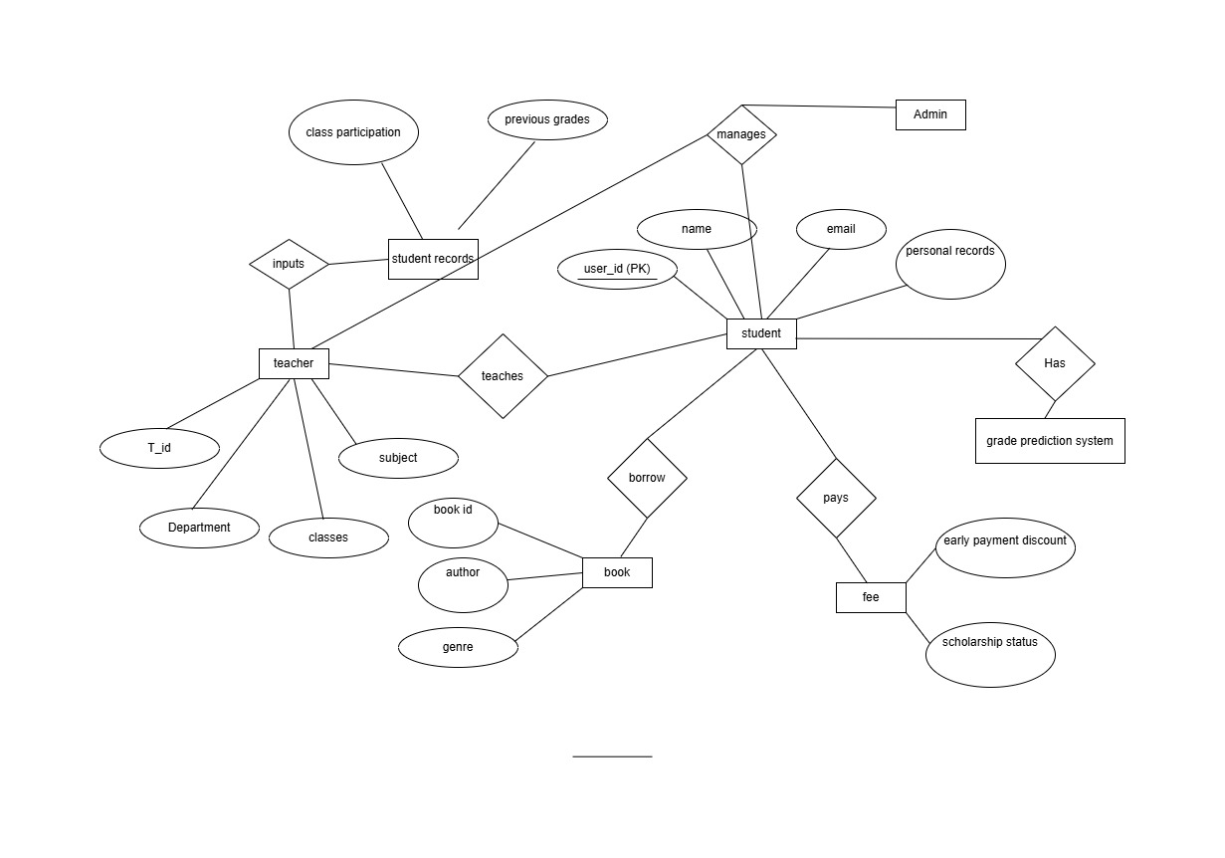

Figure 6 Level 1: Data Flow Diagram

    - Flowchart
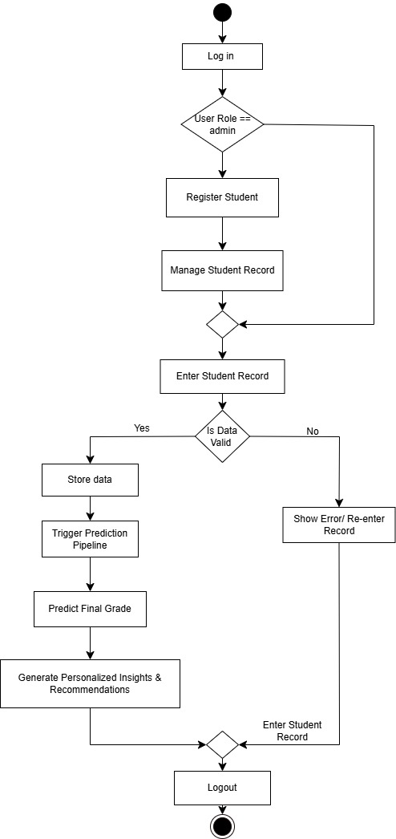

ALGORITHM DETAILS

Random Forest
Random Forest is a supervised machine learning algorithm based on ensemble learning technique. It constructs multiple decision trees during training and outputs the average prediction (for regression) or majority vote (for classification). Different random samples of the data, and their predictions are combined to reduce variance and improve accuracy. And each tree is trained on random subsets of data.
Random Forest also provides feature prediction, which identifies which input variables (features) significantly influence the target variable. It is calculated based on how much a feature reduces impurity or error across all decision trees. Hence, due to its high accuracy, ability to handle missing and noisy data, and good compatibility with structured dataset random forest is used.

Linear Regression
It is a supervised learning algorithm used to predict a continuous numerical value by modeling a linear relationship between independent variables and a dependent variable. Encoding of binary data, and categorical data will be done to fit the relationship, whereas continuous data can be used as it is.
The general equation of multiple linear regression is:
$$Y=β_{0}+β_{1}X_{1}+β_{2}X_{2}+⋯+β_{n}X_{n}+ϵ$$

IMPLEMENTATION DETAIL

Authentication Middleware
The authentication middleware is a critical component that secures routes in the application by validating user credentials before allowing access to protected resources. The middleware performs the following steps:
- Token Extraction: Upon receiving a request, the middleware checks for the presence of a JWT (JSON Web Token) in the request headers or cookies. If no token is found, the middleware returns a 401 Unauthorized response.
- Token Validation: If a token is present, the middleware decodes and validates it using a predefined secret key. During this process, the middleware checks:
2.1 Expiration: Whether the token has expired. If expired, a 401 Unauthorized response is returned.
2.2 Claims Extraction: If valid, the middleware extracts user claims, such as the username or user ID, from the token.
- Context Setting: After successfully validating the token, the middleware sets the extracted claims in the request context. This allows subsequent handlers to access user information without needing to re-validate the token.
- Next Handler Invocation: Finally, the middleware calls the next handler in the chain, allowing the request to proceed if authentication is successful.

REFERENCES

[1] | [1] S. Agyemang, E. O. Appiah, and E. A. Yirenkyi, “Predicting Students' Academic Performance Via Machine Learning Techniques,” ScholarWorks@UTRGV, 2023.  [2] “AI student success predictor: Enhancing personalized learning in campus management systems,” Computers in Human Behavior, vol. 159, Sep. 2024.  [3] T. Gray, C. Perkins, and R. Lewis, “Using learning analytics to predict student retention in higher education,” IEEE Transactions on Learning Technologies, vol. 14, 2021.  [4] J. Xu and H. Yang, “A comparative study of Random Forest and Multiple Linear Regression models in predicting student academic performance,” Expert Systems with Applications, vol. 185, 2022.  [5] A. S. M. Kayes, M. A. Islam, and P. Watters, “An empirical study of machine learning techniques for predicting student academic performance,” Education and Information Technologies, vol. 26, 2021.  [6] Paathshala, “School-College Management System Features,” 2025. [Online]. Available: https://paathshala.com.np/

APPENDICES

SCREENSHOTS

